**Input**

1) n=float(input("Enter the number"))

for i in range(1,11):

c=n*i

print(n,"*",i,"=",c)

**Output:**

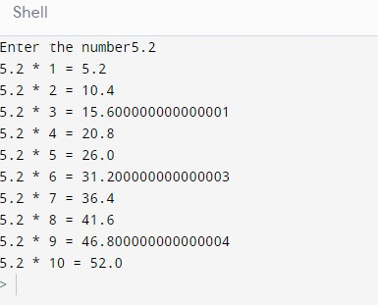

**Input:**

2) for i in range(0,50,2):

print (i)

**Output:**

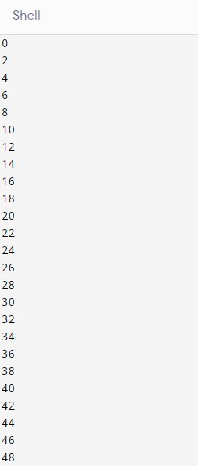

**Input:**

3) for i in range(3):

for j in range(i+1):

print ("*", end=" ")

print()

**Output:**

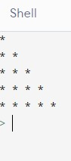

**Input:**

4) nums=[102,201,176,82.4,70.11]

c=sum(nums)

print(c)

**Output:**

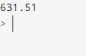

**Input:**

5) i=1

n=0

b=9

n=int(input("enter any number:"))

while i<=10:

n=n*i

print (n, 'x', i,'=', n * i)

i=i+1

**Output:**

